**ACTIVITY 5:** **Querying and Filtering Data**

**Objective:**

To know how to use arithmetic, comparison and logical operators along with the SQL

**Materials:**

PC or Laptop

WAMP/XAMPP Installer

Web Browser or CLI

**Background**

**Arithmetic Operators** can perform arithmetical operations on numeric operands involved. Below are as follows:

|  |  |  |
| --- | --- | --- |
| **Operator** | **Meaning** | **Example** |
| + (Add) | Addition | SELECT 10 + 4 |
| - (Subtract) | Subtraction | SELECT 10 - 4 |
| * (Multiply) | Multiplication | SELECT 10 * 4 |
| / (Divide) | Division | SELECT 10 / 4 |
| % (Modulo) | Returns the integer remainder of a division. For example, 17 % 5 = 2 because the remainder of 17 divided by 5 is 2. | SELECT 10 % 4 |

***NOTE*** that the + and - operators can also be used in date arithmetic

**Comparison operators** are used in the WHERE clause to determine which records to select. Here is a list of the comparison operators that you can use in MySQL:

|  |  |
| --- | --- |
| **Comparison Operator** | **Description** |
| = | Equal |
| <=> | Equal (Safe to compare NULL values) |
| <> or != | Not Equal |
| > | Greater Than |
| >= | Greater Than or Equal |
| < | Less Than |
| <= | Less Than or Equal |

**Logical Operators** enable us to use more than one condition in WHERE clause. Below are as follows:

|  |  |
| --- | --- |
| **Logical Operator** | **Description** |
| **AND** | introduce you to the AND operator to combine Boolean expressions to form a complex condition for filtering data |
| **OR** | introduce you to the OR operator and show you how to combine the OR operator with the AND operator to filter data |
| **NOT** | The operator displays a record if the condition(s) is NOT TRUE |

**Instructions:**

**Write the prescribe SQL statement for the following items. Make sure to provide a screenshot for each action you performed.**

**NOTE: Please see attached .sql file for this activity. Create a new database and import the said .sql file.**

**Arithmetic Operators**

1. Display all owners’ information and their ages after 10 years today.

**My command prompt:**

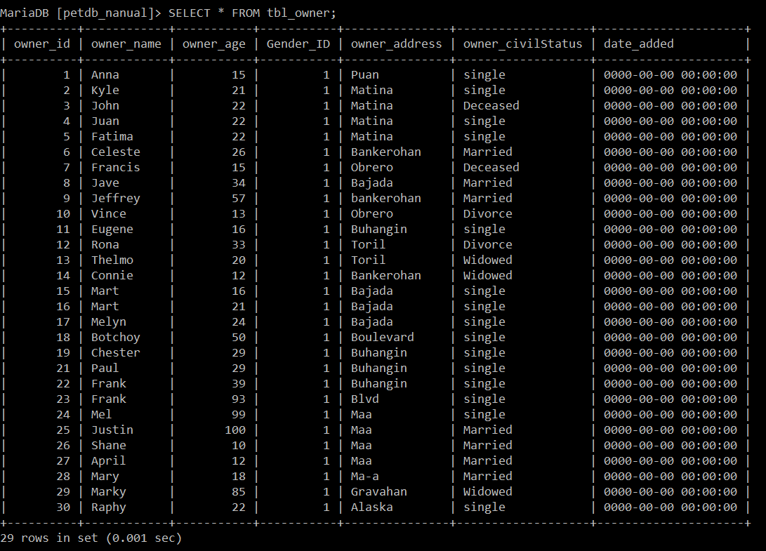

1. Show the names of the owner and half of its age.

**My command prompt:**

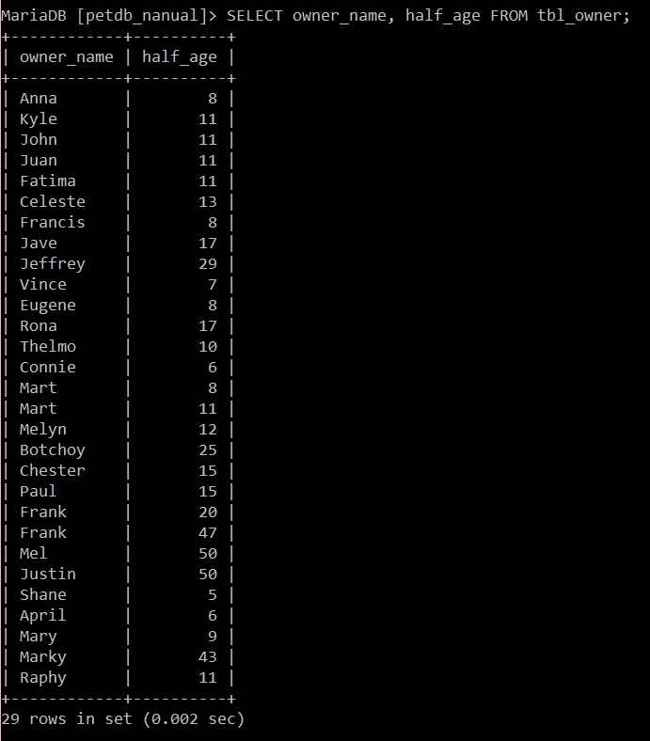

1. Display all pet’s name, price, and mark up price by 8%.

**My command prompt:**

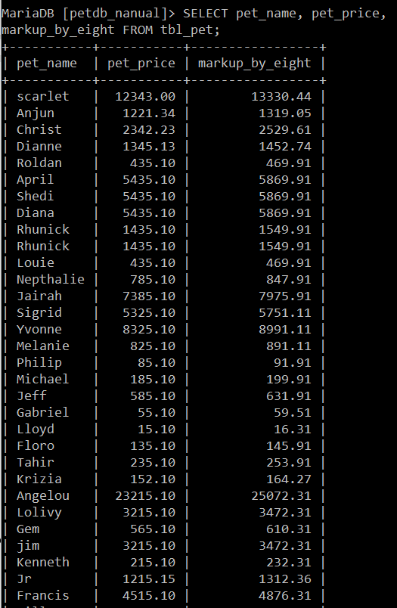 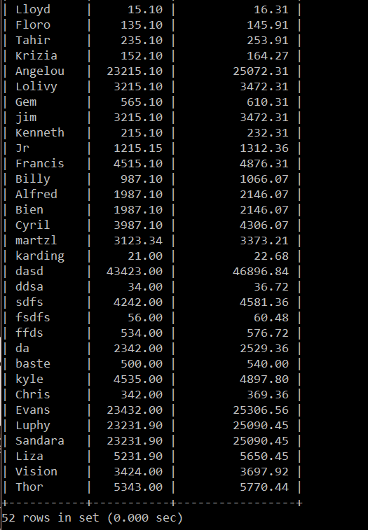

1. Display all pet’s name, age and price. Also show the change of price based on 50% discount.

**My command prompt:**

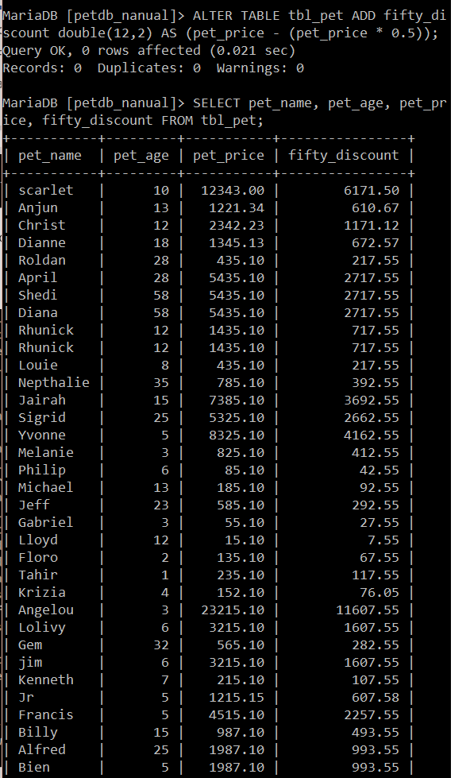 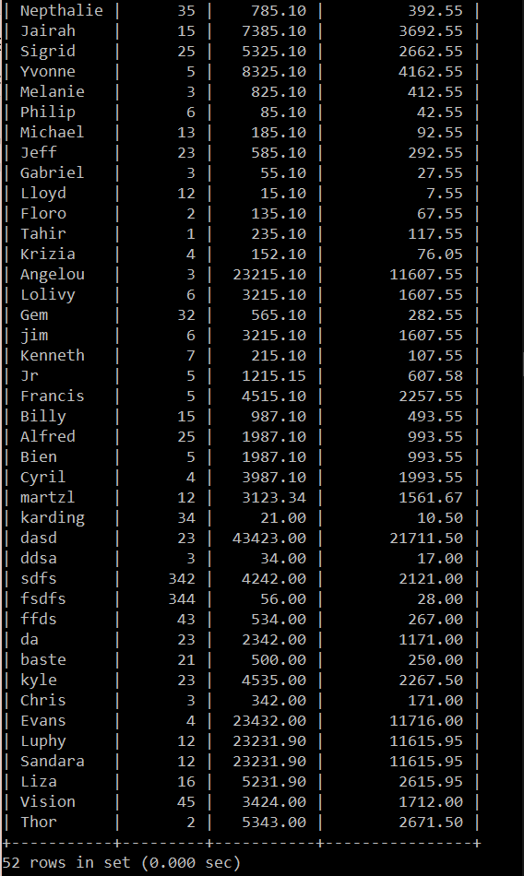

1. Show pet’s name, gender, breed, price and show how much money can be saved when there is 80% OFF for every pet.

**My command prompt:**

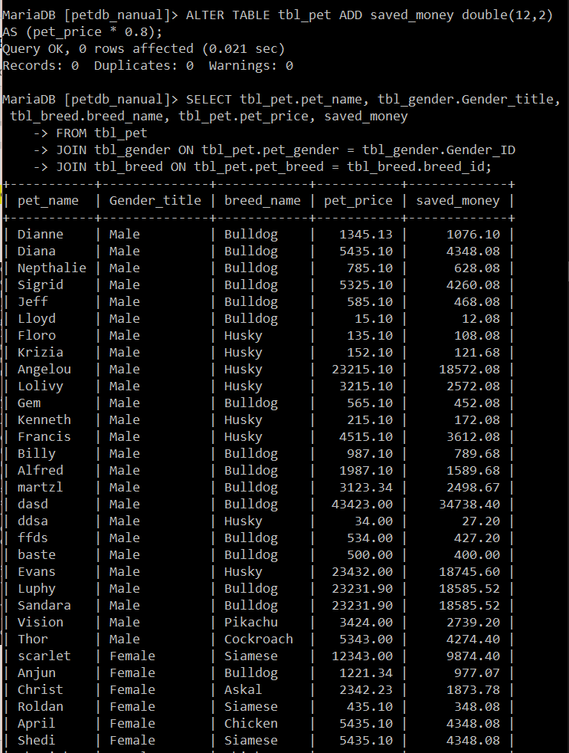 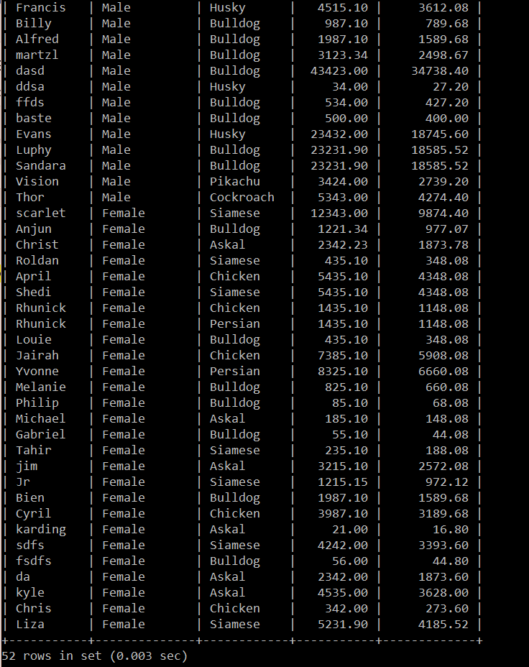

1. Display pet's name, breed, and price and new price which price increases by 55.50 each.

**My command prompt:**

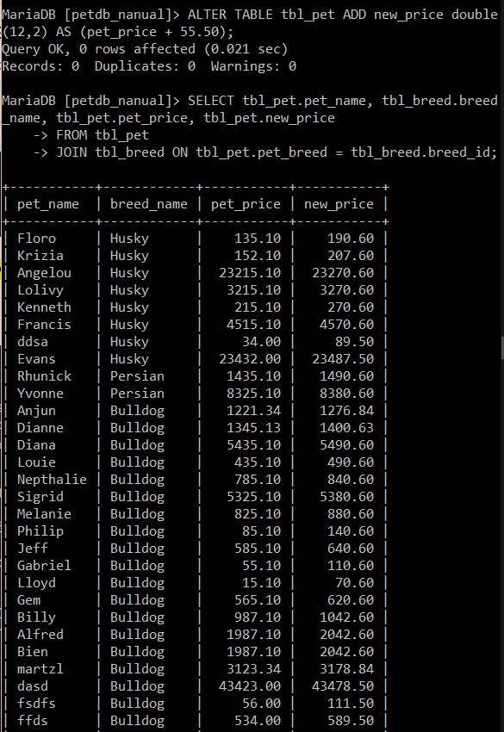 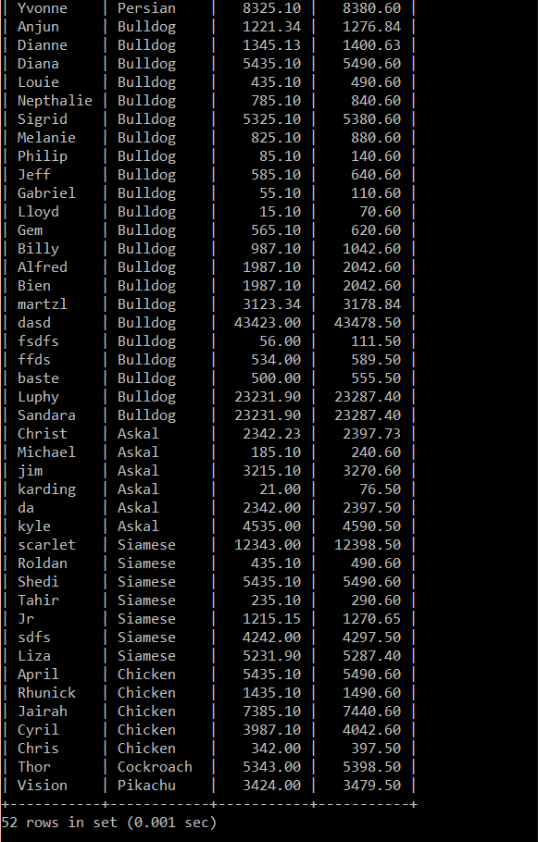

1. Display pet's name, type, age, price, and a markdown price whose price has markdown by 5.78% each.

**My command prompt:**

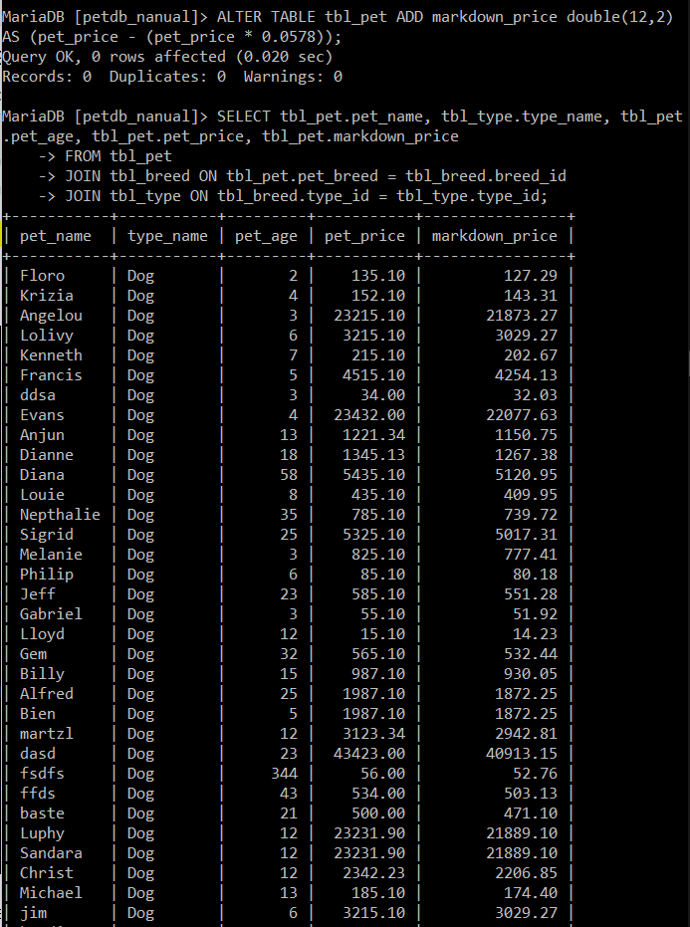 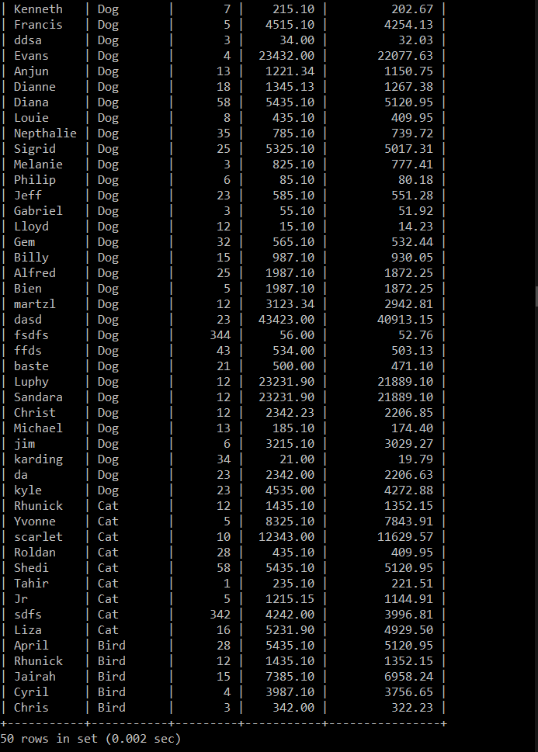

1. Display pet's name, gender, age, and color and new price if double its price.

**My command prompt:**

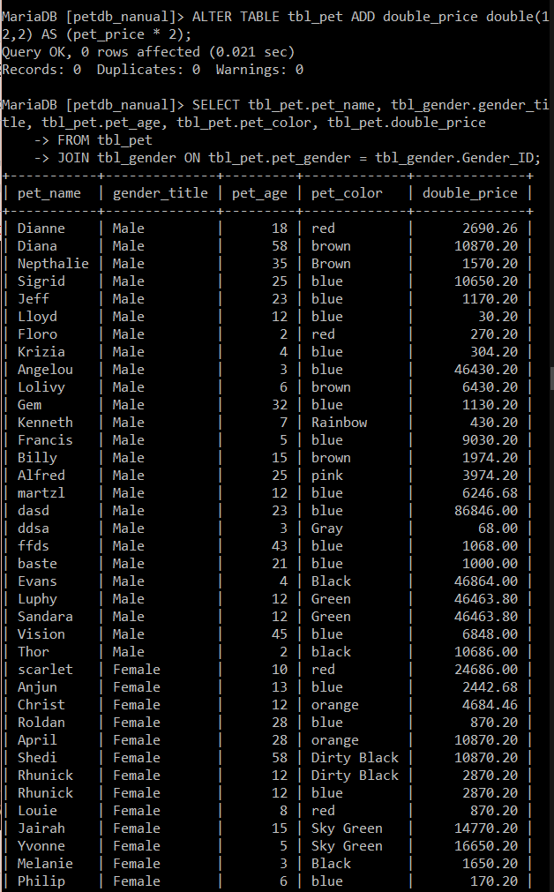 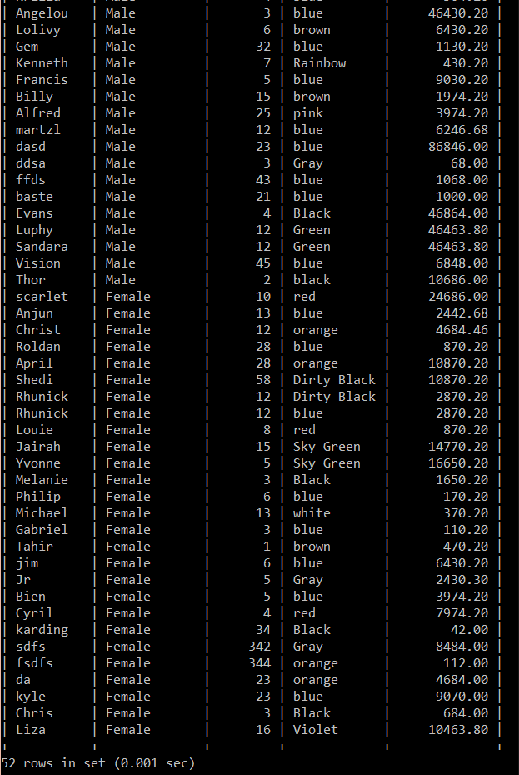

1. Display pet's name, price, and new price as (New_price) when it is cost half of its price.

**My command prompt:**

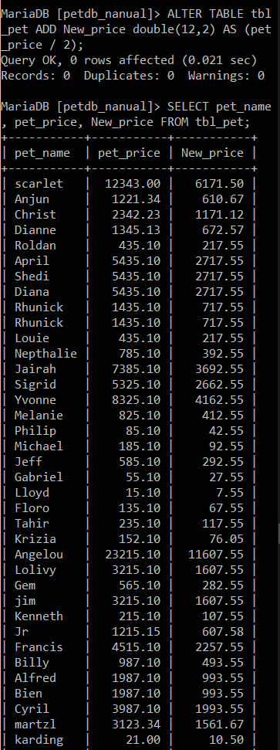 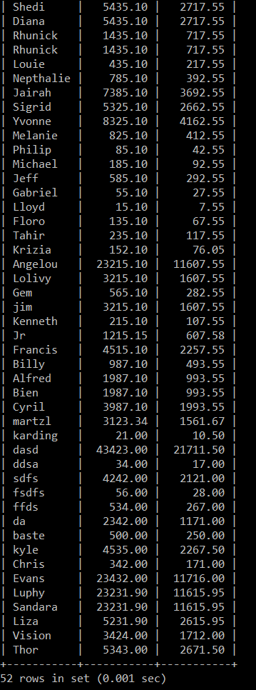

1. Display pet’s id, name, status, price. What is the remaining price when you perform % or modulus division to every pet’s price.

**My command prompt:**

**NOTE:** Since there is no value indicated in the instruction, I just used 5 as the secondary value in the modulus division expression.

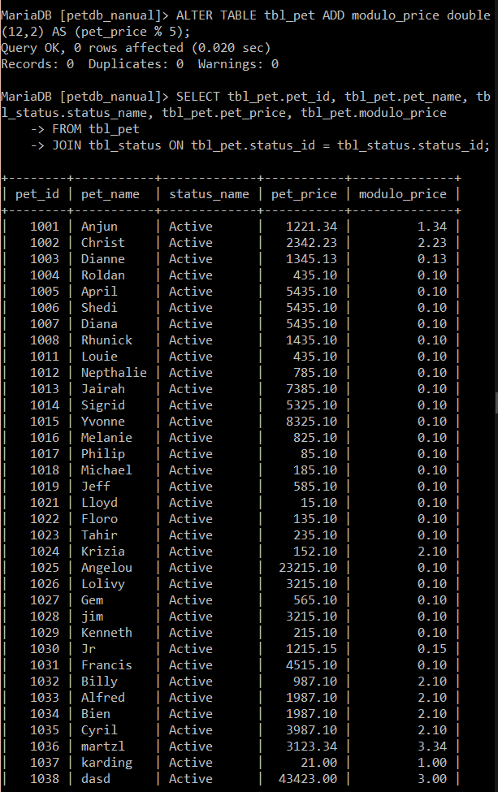 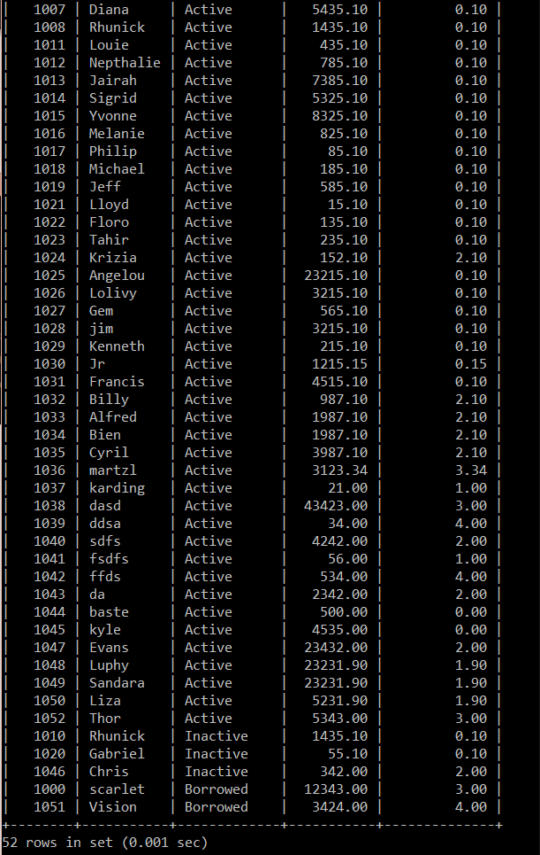

**COMPARISON Operators**

1. Find the name of all owners who lives in Bajada.

**My command prompt:**

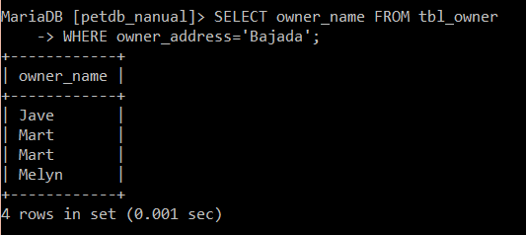

1. Find the name and age of all owners whose age is more than 18.

**My command prompt:**

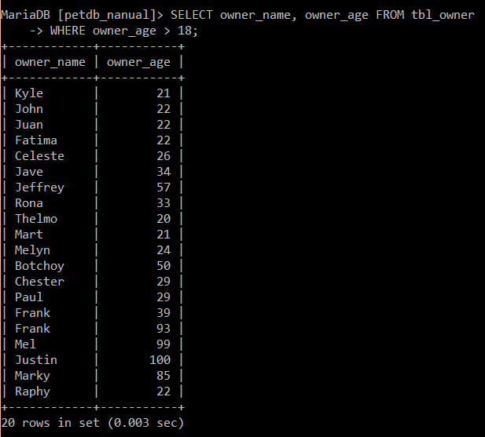

1. Find all owners who are NOT single.

**My command prompt:**

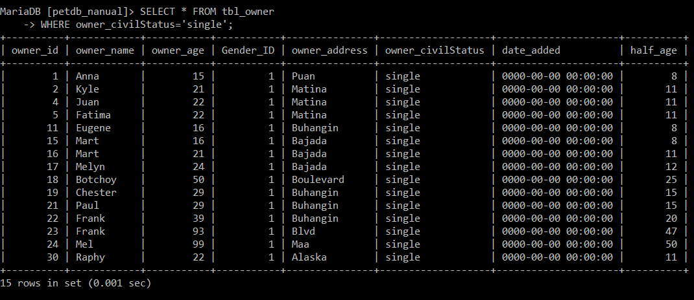

1. Display all owners whose gender is female.

**My command prompt:**

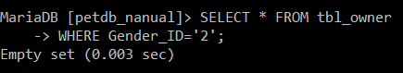

1. Find owner whose id is 3.

**My command prompt:**

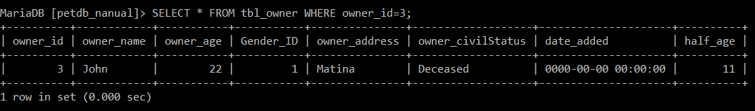

1. Find the name of all pets whose color is Pink.

**My command prompt:**

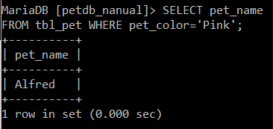

1. Display all pets whose breed is Askal.

**My command prompt:**

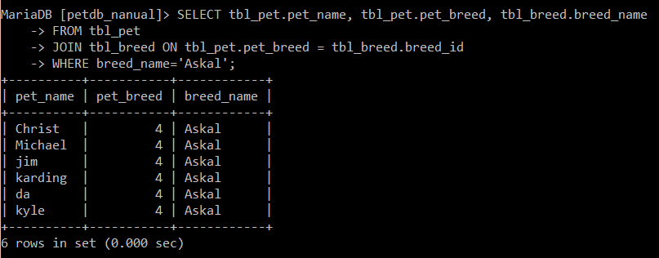

1. Display the pet's name, gender, and price whose pet type is dog.

**My command prompt:**

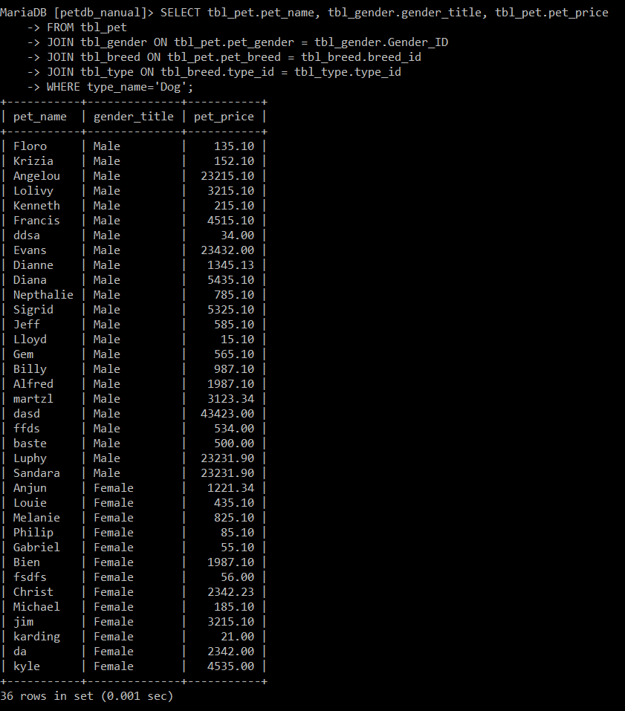 

1. Display all pets whose price is more than 10000.

**My command prompt:**

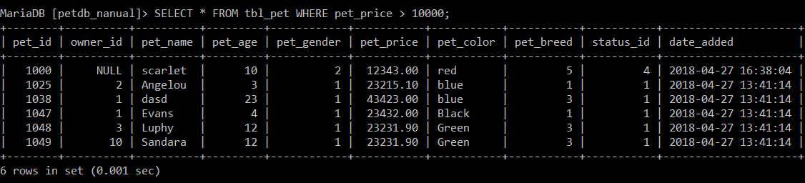

1. Display pet information whose name is Liza.

**My command prompt:**

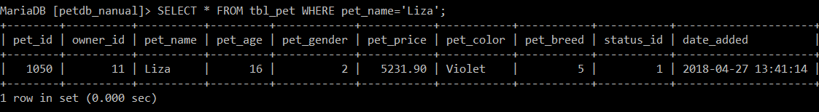

**Logical Operators**

1. Find an owner whose gender is male and age belongs to minor [if age is below 18] category.

**My command prompt:**

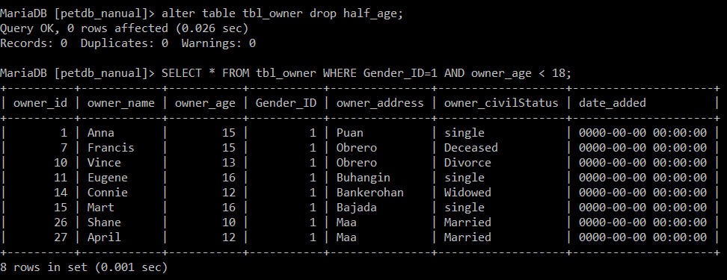

1. Show owners whose status is Married, but from Matina.

**My command prompt:**

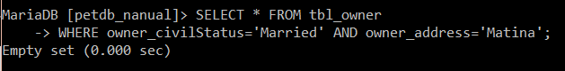

1. Show owners whose status is Single, but from Matina and is below 18 years old.

**My command prompt:**

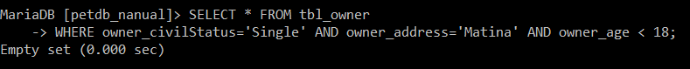

1. Find owners whose status is Male and Single.

**My command prompt:**

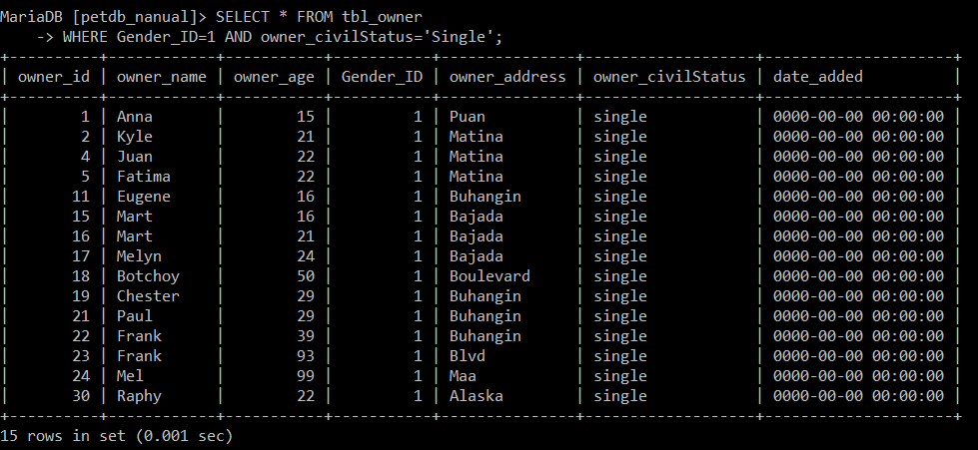

1. Display owners who are Divorce female whose age may NOT be more than 30. She must live in Obrero.

**My command prompt:**



1. Find a pet whose age is between 5 and 15.

**My command prompt:**

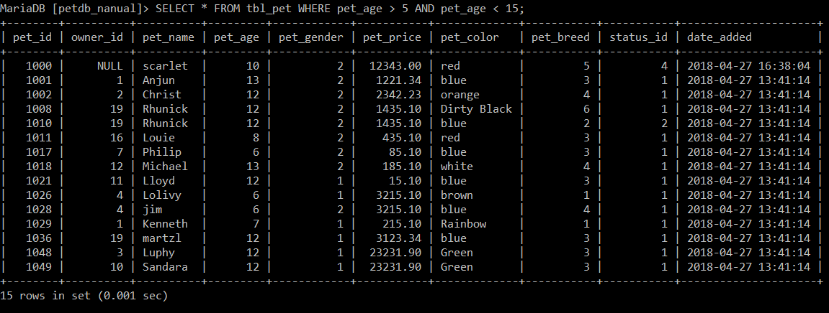

1. Display pet's information whose gender is female and color is red.

**My command prompt:**

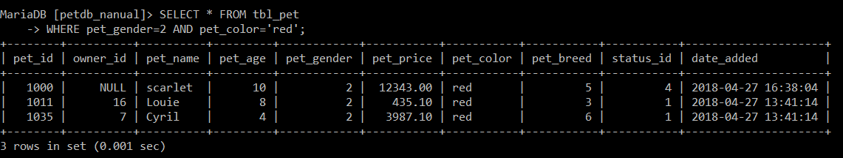

1. Find the name and gender of the pet whose breed is either dachshund or Labrador.

**My command prompt:**

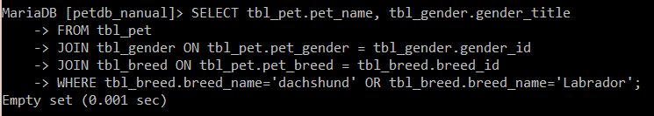

1. Find all dead pets.

**My command prompt:**

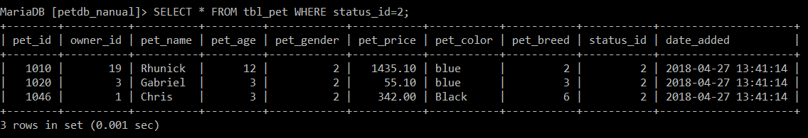

1. Find all active pets whose type is dog.

**My command prompt:**

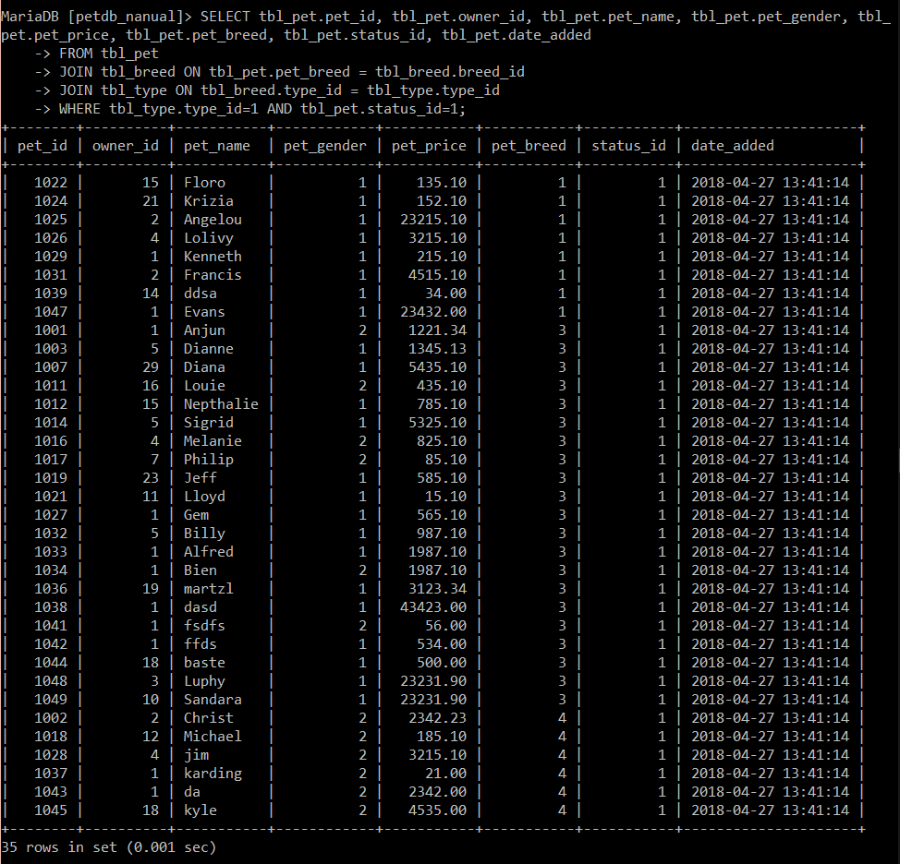

1. Find all active male pets whose type is cat.

**My command prompt:**

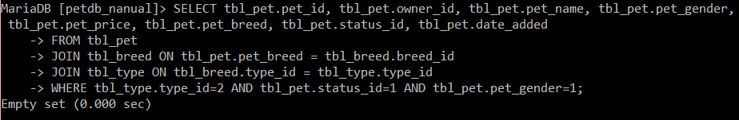

1. Find all active male pets whose type is cat but must be a Persian.

**My command prompt:**

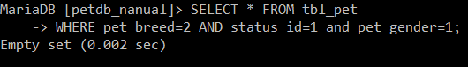

1. Which pets are NOT Dog? Show all pet’s information.

**My command prompt:**

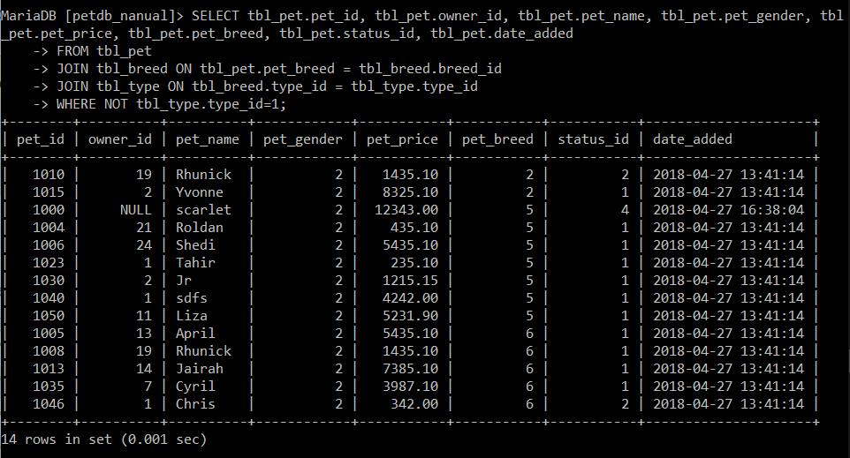

1. Show all pet’s information EXCEPT to those who are dog.

**My command prompt:**



1. Find the name of the pet whose age is more than 10. The pet’s type must be dog and its color should all blue.

**My command prompt:**

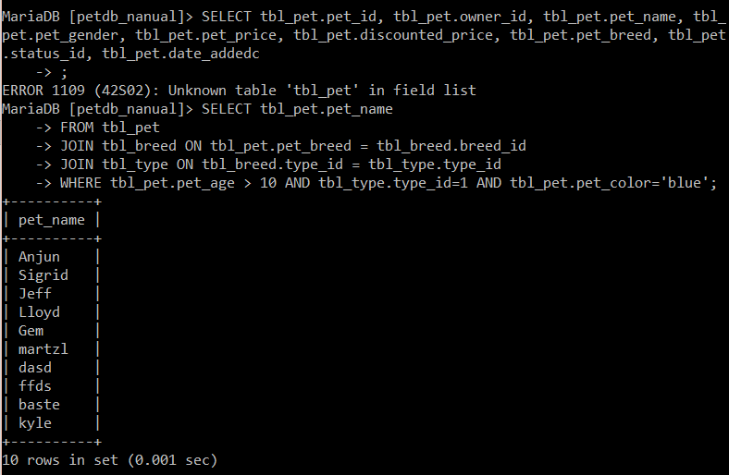

1. Display the pet’s name, type, breed, age, price, and mark down price value if it has 10% OFF. Make sure that the pet must be dog ONLY.

**My command prompt:**

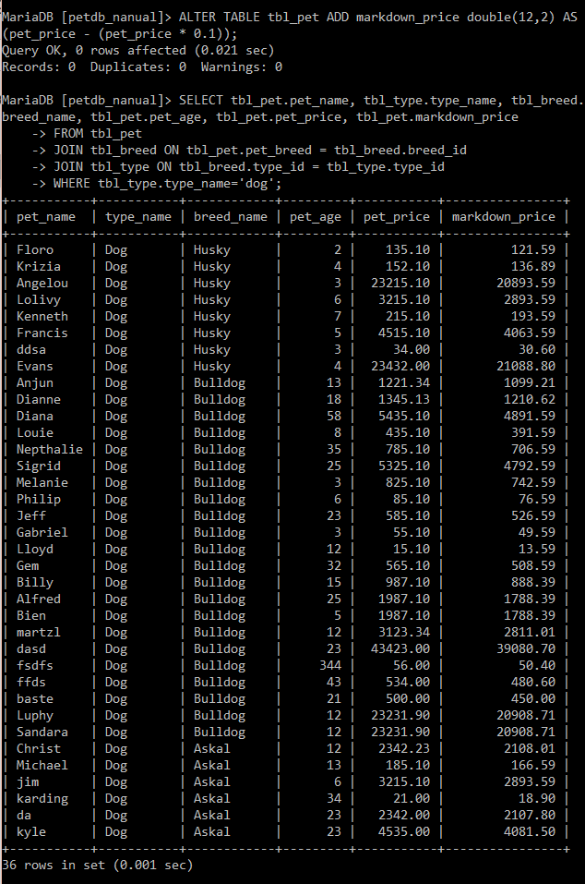

1. All active bird must be sold with a 50% OFF discounted price. Show the bird’s information and the new price.

**My command prompt:**

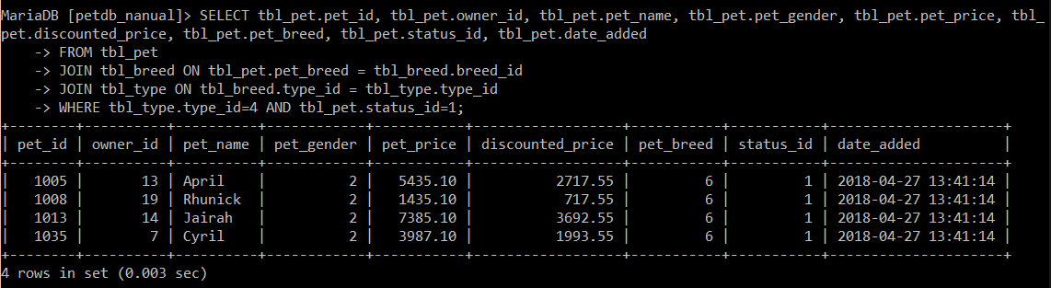

1. Change all inactive pet’s price to 0.00.

**My command prompt:**

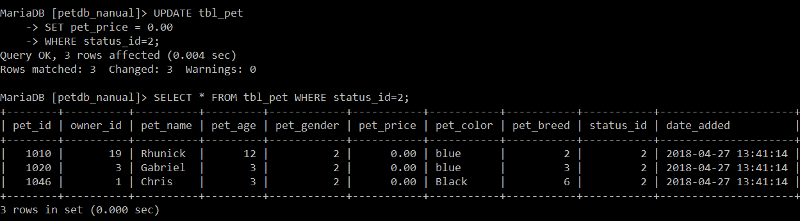

1. Sandara is found yesterday, change her status now.

**My command prompt:**

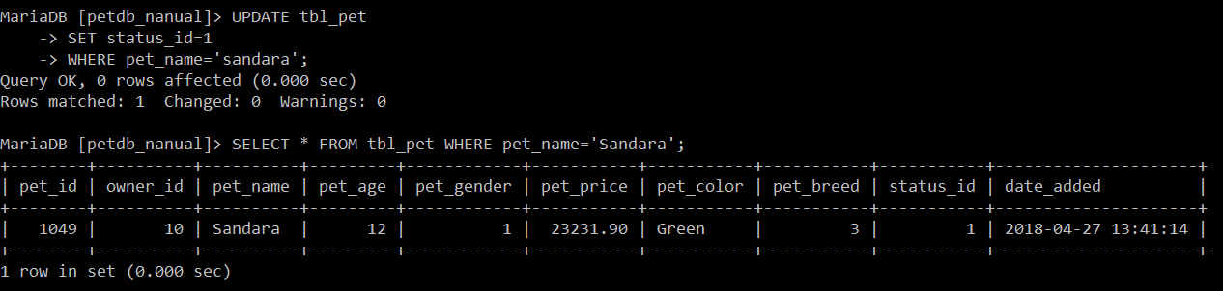

1. Show the list of pet’s information whose owner is

**My command prompt:**

